**HEART BEAT DETECTOR USING ARDUINO**

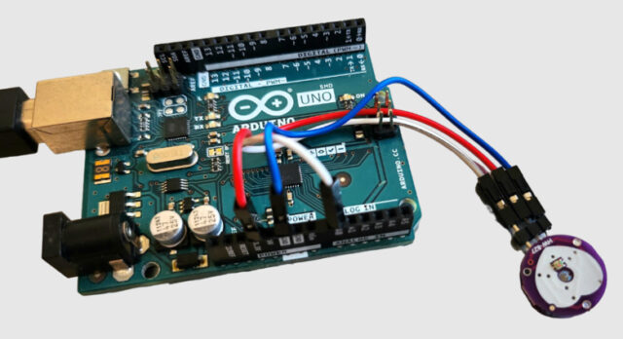

**Components/Hardware Required**

We need following components for this project. All the components can be purchased from the given links.

| **S.N.** | **Components** | **Quantity** |
| --- | --- | --- |
| 1 | Arduino UNO Board | 1 |
| 2 | Pulse Sensor | 1 |
| 3 | 16X2 I2C LCD Display | 1 |
| 4 | Jumper Wires | 10 |
| 5 | Breadboard | 1 |
|  |  |  |

### ****Pulse Sensor****

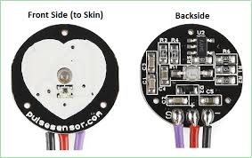

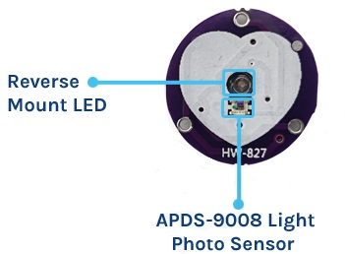

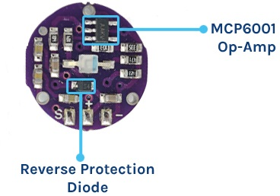

#### **Working of the Pulse Sensor**

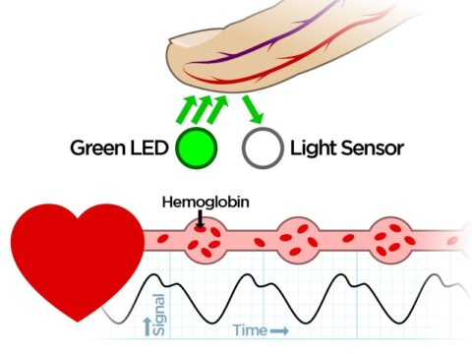

#### **Pulse Sensor PinOut**

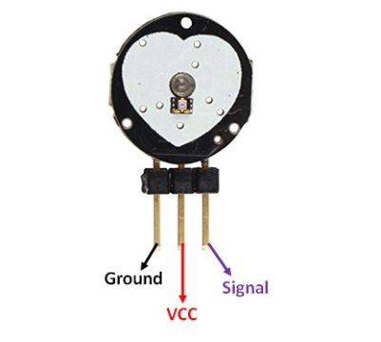

### ****Interfacing Pulse Sensor with Arduino****

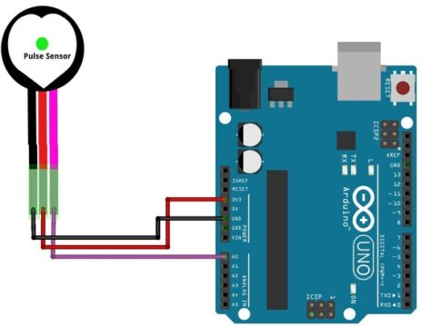



#### **Pulse Sensor Library Installation**

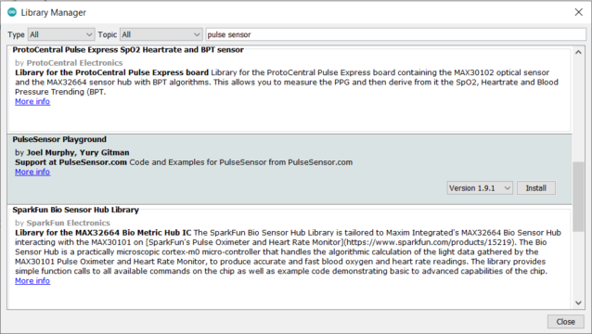

Download the PulseSensor Playground Library from the Arduino IDE (Go to Sketch -> Include Library -> Manage Libraries, then search for “PulseSensor Playground” and install it).

#### **Source Code/Program**

Open the example sketch that comes with the library (Go to File -> Examples -> PulseSensor Playground -> GettingStartedProject).

*// Include necessary libraries*

#define USE_ARDUINO_INTERRUPTS true

#include <PulseSensorPlayground.h>

#include <LiquidCrystal_I2C.h>

LiquidCrystal_I2C lcd(0x27, 16, 2); *// set the LCD address to 0x27 for a 16 chars and 2 line display*

*// Constants*

const **int** PULSE_SENSOR_PIN = 0;  *// Analog PIN where the PulseSensor is connected*

const **int** LED_PIN = 13;          *// On-board LED PIN*

const **int** THRESHOLD = 550;       *// Threshold for detecting a heartbeat*

*// Create PulseSensorPlayground object*

PulseSensorPlayground pulseSensor;

**void** setup()

{

*// Initialize Serial Monitor*

  Serial.begin(9600);

  lcd.init();

  lcd.backlight();

*// Configure PulseSensor*

  pulseSensor.analogInput(PULSE_SENSOR_PIN);

  pulseSensor.blinkOnPulse(LED_PIN);

  pulseSensor.setThreshold(THRESHOLD);

*// Check if PulseSensor is initialized*

**if** (pulseSensor.begin())

  {

    Serial.println("PulseSensor object created successfully!");

  }

}

**void** loop()

{

  lcd.setCursor(0, 0);

  lcd.print("Heart Rate");

*// Get the current Beats Per Minute (BPM)*

**int** currentBPM = pulseSensor.getBeatsPerMinute();

*// Check if a heartbeat is detected*

**if** (pulseSensor.sawStartOfBeat())

  {

    Serial.println("♥ A HeartBeat Happened!");

    Serial.print("BPM: ");

    Serial.println(currentBPM);

    lcd.clear();

    lcd.setCursor(0, 1);

    lcd.print("BPM: ");

    lcd.print(currentBPM);

  }

*// Add a small delay to reduce CPU usage*

  delay(20);

}

#### **Testing & Results**

